Name: ______________________________________________________________ Hour: _______ Date: ___________

**Driving Question: What is the relationship between the motion of an object and force**?

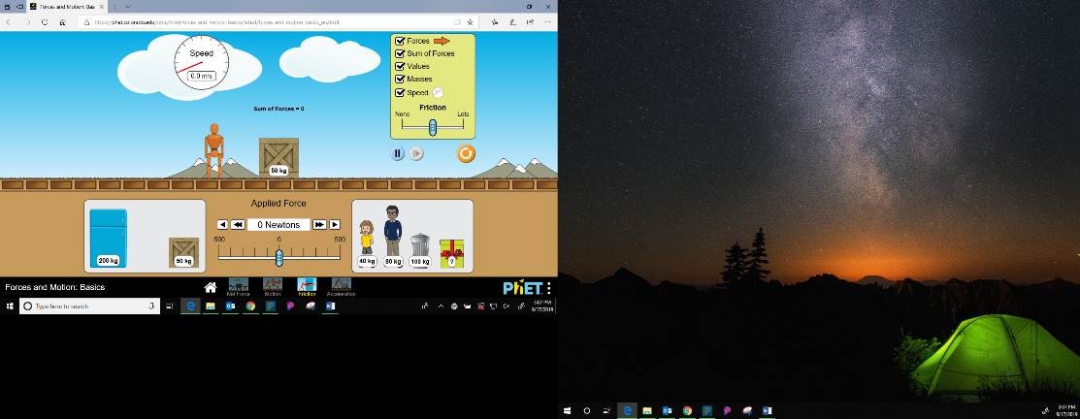Phet 🡪 Physics Sims 🡪 Forces and Motion: Basics 🡪 FRICTION tab

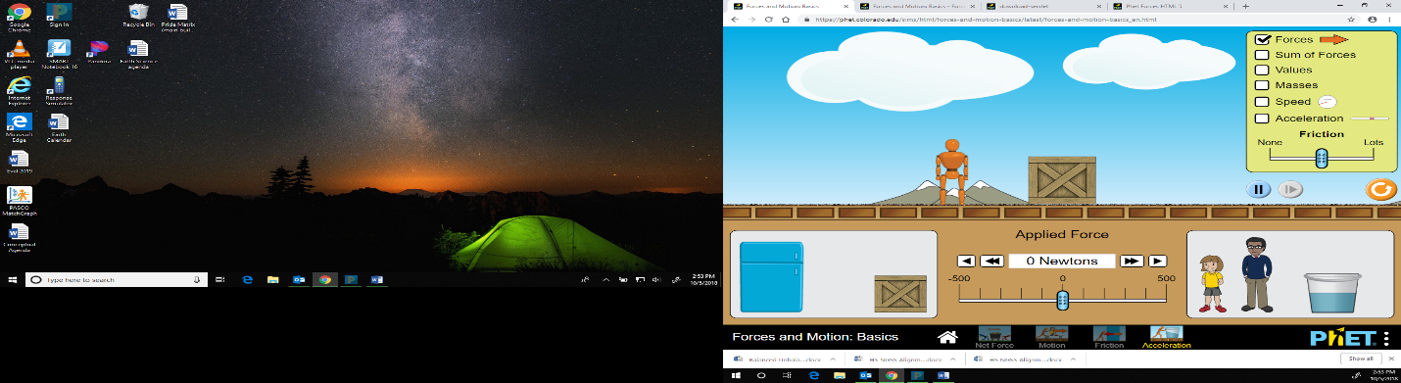Click all of the options in the upper right hand menu.   
Use the arrows in this menu to the left to control the value of the Force Applied.

**You will have to RESET all of these menus for EACH scenario!**

|  |  |
| --- | --- |
| **Scenario 1:** Move Friction to NONE. Put an applied force on the box of 10 Newtons.  Make your observations about the following:  Draw a Free-body Diagram:  Total Force (Including Direction)  Speed  Acceleration  Mass | **Scenario 2:** Press Reset. Move Friction to NONE. Put an applied force on the box of 30 Newtons.  Make your observations about the following:  Draw a Free-body Diagram:  Total Force (Including Direction)  Speed  Acceleration  Mass |
| **Scenario 3:** Press Reset. Move friction to NONE. Drag the box to the lower left and exchange it with the 200kg Mass. Apply 10 Newtons of force.  Make your observations about the following:  Draw a Free-body Diagram:  Total Force (Including Direction)  Speed  Acceleration  Mass | **Scenario 4**: Press Reset. Move the friction to NONE. Drag the box to the lower left and exchange it with the 200kg Mass. Apply 30 Newtons of force.  Make your observations about the following:  Draw a Free-body Diagram:  Total Force (Including Direction)  Speed  Acceleration  Mass |
| **Summary**  **Compare the observations of scenarios 1 and 3. What are some similarities and differences?**  **Similarities**  **Differences** | **Summary**  **Compare the observations of scenarios 2 and 4. What are some similarities and differences?**  **Similarities**  **Differences** |

|  |  |
| --- | --- |
| **Real-life Example**  **Draw and explain a real-life example that represents scenario 1 and 3.** | **Real-life Example**  **Draw and explain a real-life example that represents scenario 2 and 4.** |

**Applying:**

1. Accelerations are produced by _____________________

**2** How does acceleration of an object change in relation to its mass? It is

|  |  |  |  |
| --- | --- | --- | --- |
| **A** | directly proportional. | **B** | inversely proportional. |

**3** The acceleration produced by a net force on an object is

|  |  |  |
| --- | --- | --- |
| **A** | | inversely proportional to the mass of the object. |
| **B** | directly proportional to the magnitude of the net force. | |
| **C** | in the same direction as the net force. | |

1. How did the mass of the object effect the force at which you had to push the object to get it to move?   
   ***If you forgot, use the simulation to test it. Try to push the box vs the refrigerator with the same force.***

a. the amount of force stayed the same.

b. the amount of force needed to be increased.

c. amount of force needed to be decreased.

1. Put the following objects in the order from greatest to least for the **amount of force** needed to move the object.

MC900250821[1]MC900013091[1] MC900264574[1] 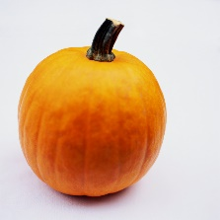 ______________________________________

15kg 2kg 10kg 4kg

A B C D

1. Think about your ranking in the previous question. Which one would require the greatest amount of force to get the object to stop?

_________________________ Why?

1. Based on your observations, what is the **relationship (equation)** between Force, Mass and Acceleration of an object?

F = Force (N or kg*m/s)) M = Mass (kg) A = Acceleration (m/s2)

1. Use your equation to solve for the amount of force needed to move a 50kg desk with an acceleration of 2m/s2.

**Givens:**