Name __________________________
Force and Motion
Driving Question : What causes motion and what does it look like graphically and mathematically.

- The graph below show cyclist riding at different points in time.
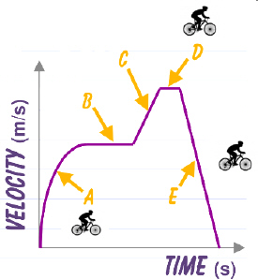
Describe the motion of the cyclist at each letter.

At the End.

Draw free body diagrams to represent the forces acting on the bike at A, D, & E and at the end of their ride.
A. D.
E. END

2. | The velocity time graph below depicts the motion of a car as as you drive home from school.  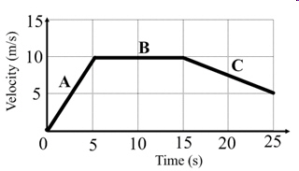  Determine the velocity of the car at the following moments in time. Show all work – Givens, Formula, work and final answer with unit. Does your answer make sense!!! EXPLAIN!  t = 3 s t = 8 s t = 17 s  Determine the acceleration of the car at the following intervals of time. Show all work – Givens, Formula, work and final answer with unit. Does your answer make sense!!! EXPLAIN!  t = 0 s - 5 s t = 5 s = 15 s t = 15 s - 20 s  - The graph below shows the motion falling from a rope while scaling a wall. Describe the motion of the object to the right of the graph and then draw a free-body diagram below the graph.  Your teacher’s car can go from rest to 35 m/s in 10 seconds. The car’s velocity changes at a constant rate.  a. Construct a velocity vs. time graph to represent the motion of the car.  b. Determine the acceleration of the car. Show all work – Givens, equations, work with units in final answer.  c. How fast is the car going 3 seconds after it starts? Show all work – Givens, equations, work with units in final answer.  - From the graph below. Draw the corresponding motion of the object to the right. Describe the motion next to the graphs.  Are you ready for your test? It involves everything you have learned up to this point with force and motion. ______________________________________________________________________________________________________________________________________________________________________

