CHIPPEWA VALLEY GIRLS BASKETBALL
Varsity Head Coach: Jackie Maurer email: jmaurer@cvs.k12.mi.us
JV Coach: Tara Moran email: tmoran@cvs.k12.mi.us
Freshman Coach: Mike Matway email: mmatway@cvs.k12.mi.us

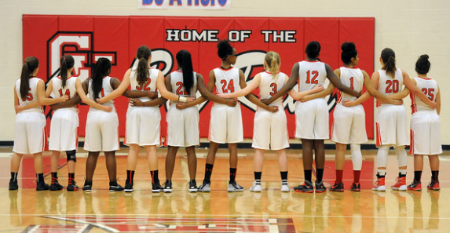

Chippewa Valley Girls Basketball Try-out Information
TO PARTICIPATE IN TRY-OUTS YOU MUST have a Participation Card
A Participation Card informs coaches that you have a current physical, are academically eligible, and you do not have any fines. Cards will be available for pick up in the athletic office starting, November 3rd.

CONDITIONING (all athletes)
- No team conditioning due to COVID…condition on own with mask on!

Be On Time: On time means you are here at least 15 minutes before the scheduled start time – this includes being taped with shoes on at least 15 minutes prior to the start time.

JV/VARSITY TRY-OUTS
(Returning Players, 10th, 11th & 12th Graders or by Invite)
- MONDAY, November 9th: 3:30 – 6:30 in Main Gym
- TUESDAY, November 10th: 3:30 – 6:30 in Main Gym
- WEDNESDAY, November 11th: 3:30 – 6:30 in Main Gym

